Consuming Remote Data

1.Retrieve all students (“Method GET”)

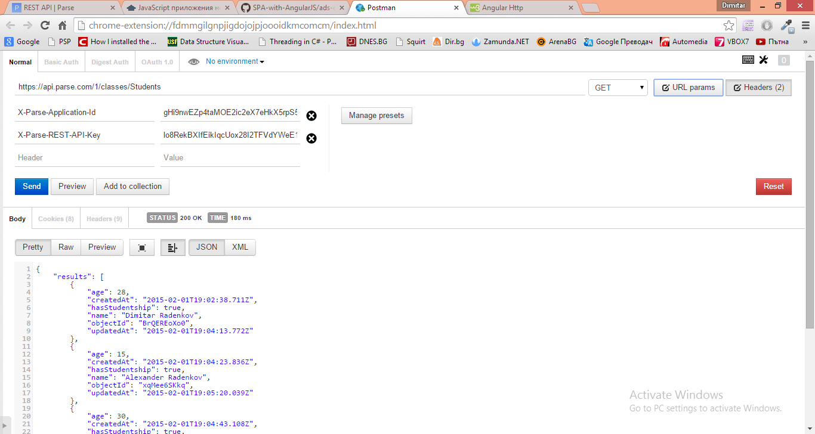

2.Add a student (“Method POST”)

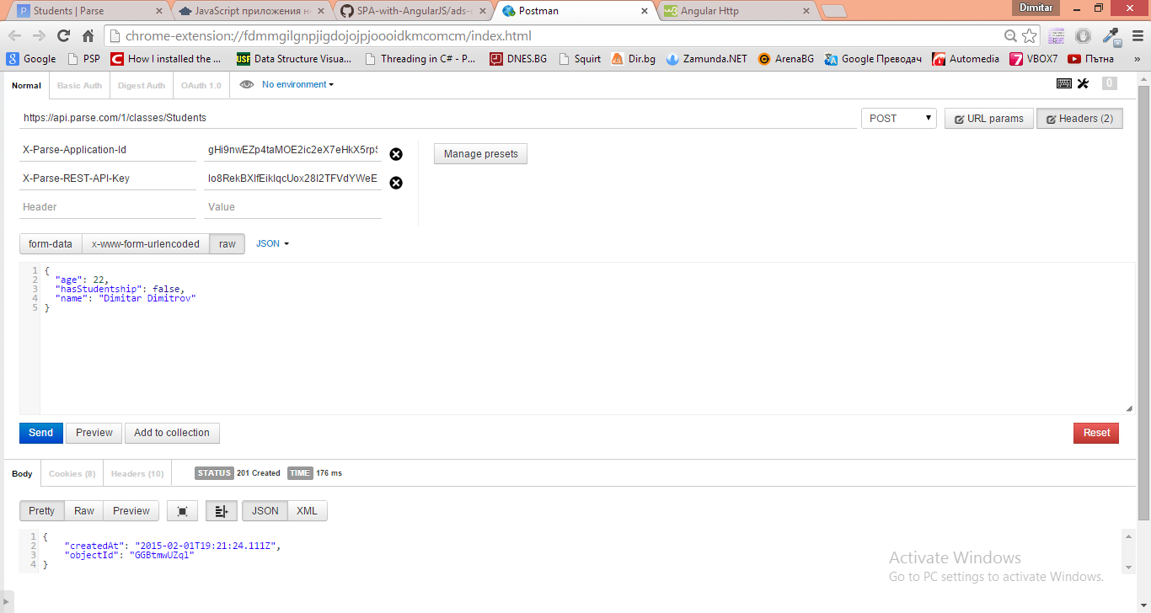

3.Update (“Method PUT”)

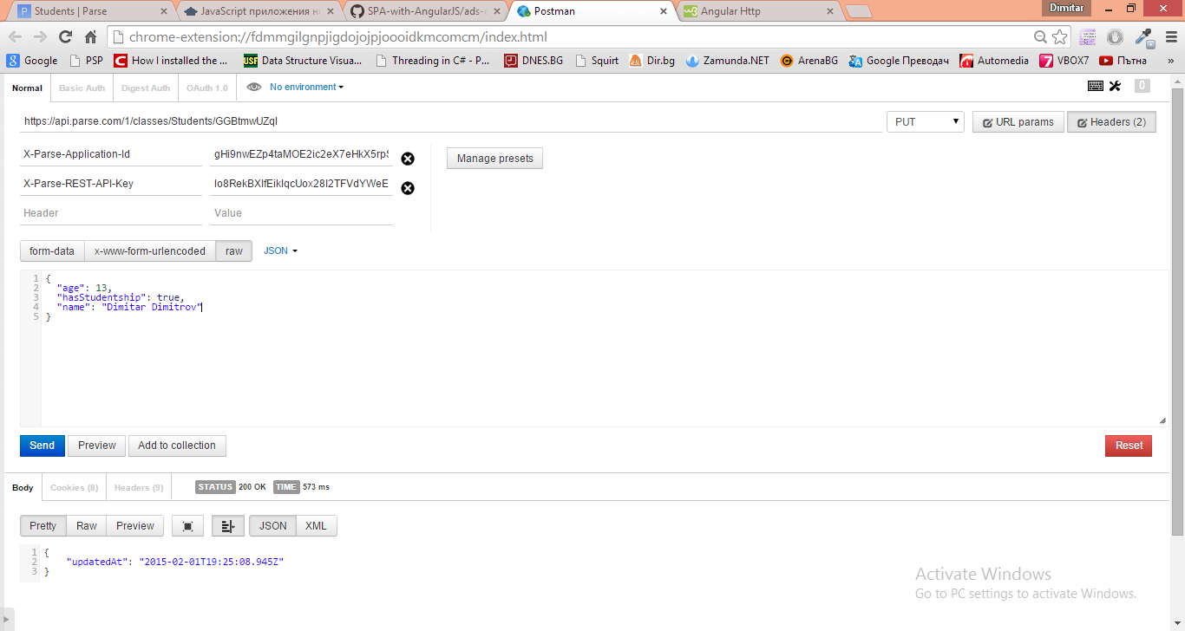

4.Delete a book (“Method DELETE”)

